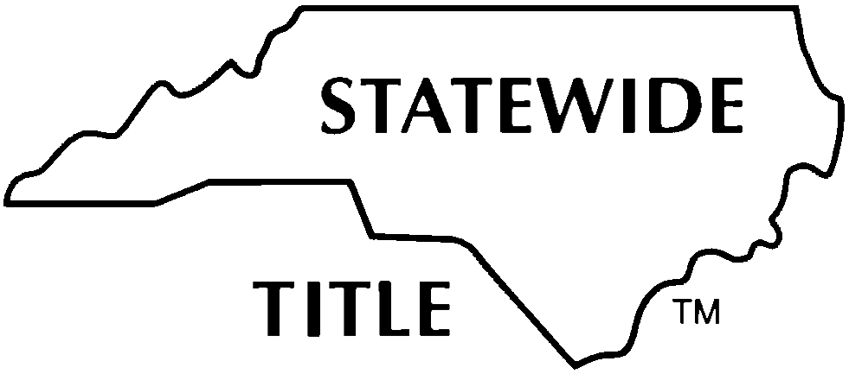
STATEWIDE TITLE, INC.
OWNER AFFIDAVIT AND INDEMNITY AGREEMENT
(NO RECENT IMPROVEMENTS AND NO EXECUTORY CONTRACTS FOR IMPROVEMENTS)

PARTIES: All parties identified in this section must execute this Agreement.

Owner:
(NOTE: A separate Agreement is required for each successive owner in the 120-Day Lien Period.)

PROPERTY:

(Insert street address or brief description and/or attach a description as Exhibit A. Include here any real estate that is a portion of a larger, previously unsegregated tract when that area is reasonably necessary for the convenient use and occupation of Improvements on the larger tract.)

DEFINITIONS: The following capitalized terms as used in this Agreement shall have the following meanings:
- Improvement: All or any part of any building, structure, erection, alteration, demolition, excavation, clearing, grading, filling, or landscaping, including trees and shrubbery, driveways, and private roadways on the Property as defined below.
- Labor, Services or Materials: ALL labor, services, materials for which a lien can be claimed under NCGS Chapter 44A, Article 2, including but not limited to professional design services (including architectural, engineering, landscaping and surveying) and/or rental equipment.
- Contractor: Any person or entity who has performed or furnished or has contracted to perform or furnish Labor, Services or Materials pursuant to a contract, either express or implied, with the Owner of real property for the making of an Improvement thereon. (Note that services by architects, engineers, landscapers, surveyors, furnishers of rental equipment and contracts for construction on Property of Improvements are often provided before there is visible evidence of construction.)
- 120-Day Lien Period: The 120 days immediately preceding the date of recordation of the latter of the deed to purchaser or deed of trust to lender in the Office of the Register of Deeds of the county in which the Property is located.
- Owner: Any person or entity, as defined in NCGS Chapter 44A, Article 2, who has or has had any interest in the Property within the 120-Day Lien Period. For the purposes of this Agreement, the term Owner includes: (i) a seller of the Property or a borrower under a loan agreement secured by the Property; (ii) a person with rights to purchase the Property under a contract and for whom an Improvement is made and who ordered the Improvement to be made; and (iii) the Owner’s successors in interest and agents of the Owner acting within their authority.
- Company: The title insurance company providing the title policy for the transaction contemplated by the parties herein.
- Property: The real estate described above or on Exhibit A and any leaseholds, tenements, hereditaments, and improvements placed thereon.
- All defined terms shall include the singular or plural as required by context.
AGREEMENT: For good and valuable consideration, the receipt and sufficiency of which is hereby acknowledged, and as an inducement to the purchase of the Property by a purchaser and/or the making of a loan by a lender secured by a deed of trust encumbering the Property and the issuance of a title insurance policy or policies by Company insuring title to the Property without exception to liens for Labor, Services or Materials; Owner first being duly sworn, deposes, says and agrees:

1. Certifications: Owner certifies that at no time during the 120-Day Lien Period have any Labor, Services or Materials been furnished in connection with a contract, express or implied, for Improvements to the Property (including architectural, engineering, landscaping or surveying services or materials or rental equipment for which a lien can be claimed under NCGS Chapter 44A) nor have any Labor, Services or Materials been furnished on the Property prior to the 120-Day Lien Period that will or may be completed after the date of this affidavit OR only minor repairs and/or alterations to pre-existing Improvements have been made and Owner certifies such repairs and/or alterations have been completed and those providing Labor, Services or Materials for the repairs have been paid in full. The Owner further certifies that no Mechanics Lien Agent has been appointed.

2. Reliance and Indemnification: This Agreement may be relied upon by the purchaser in the purchase of the Property, a lender to make a loan secured by a deed of trust encumbering the Property and by Company in issuance of a title insurance policy or policies insuring title to the Property without exception to matters certified in this Agreement. The provisions of this Agreement shall survive the disbursement of funds and closing of this transaction and shall be binding upon Owner and anyone claiming by, through or under Owner.

Owner agrees to indemnify and hold purchaser, lender, and Company harmless of and from any and all loss, cost, damage and expense of every kind, and attorney’s fees, costs and expenses, which the purchaser, lender or Company shall or may incur or become liable for, directly or indirectly, as a result of reliance on the certifications of Owner made herein or in enforcement of the Company’s rights hereunder.

3. NCLTA Copyright and Entire Agreement: This Agreement and any attachments hereto represent the entire agreement between the Owner and the Company, and no prior or contemporaneous agreement or understanding inconsistent herewith (whether oral or written) pertaining to such matters is effective.
THIS IS A COPYRIGHT FORM and any variances in the form provisions hereof must be specifically stated in the blank below and agreed to in writing by the Company.

No modification of this Agreement, and no waiver of any of its terms or conditions, shall be effective unless made in writing and approved by the Company.

PROVIDING A FALSE AFFIDAVIT IS A CRIMINAL OFFENSE
EXECUTION BY OWNER
(SEAL)  By:  Printed or Typed Name/Title:  By:  Printed or Typed Name/Title: | State of County of  Signed and sworn to (or affirmed) before me this day by  [insert name(s) of principal(s)].  Date:  , Notary Public  My Commission Expires: | (Affix Official/Notarial Seal)

INSTRUCTIONS FOR COMPLETION OF
OWNER AFFIDAVIT AND INDEMNITY AGREEMENT
(NO RECENT IMPROVEMENTS AND NO EXECUTORY CONTRACTS FOR IMPROVEMENTS)

- This Owner Affidavit and Indemnity Agreement (the “Agreement”) form is for use with any title insurer (the “Company”) regarding owner and lender coverage for transactions affecting title to particular real estate in North Carolina (the “Property”), a description of which must be included in this Agreement, where there have been no Improvements made to the Property within the 120-Day Lien Period (as defined).

- The closing attorney must notify underwriting counsel for the Company prior to closing regarding any filed Claim of Lien on Real Property or Notice of Claim of Lien upon Funds, or any Notice of Claim of Lien upon Funds known by the attorney or Owner to have been delivered to the Owner, whether on the Property or on any property in the state of North Carolina, as this may affect the Company’s decisions about whether to insure and on what basis.

At the very least, any filed Claim of Lien on Real Property must be paid in full and canceled of record. Any delivered or filed Notice of Claim of Lien upon Funds (by a subcontractor) must be paid in full and a waiver obtained from the subcontractor. The attorney must discuss any questions or issues regarding these with underwriting counsel for the Company prior to closing.

- This form is appropriate for use in transactions wherein no recent Improvements have been made on the Property. If Labor, Services or Materials (including surveying, architectural, engineering services or rental equipment) for Improvements to the Property have been provided within the 120-Day Lien Period (as defined in the Agreement) (other than minor repairs to existing Improvements completed by Owner without the assistance of a Contractor or supplier, or with evidence of payment at or before closing of completed work), then either the
- NCLTA Form #2: OWNER/CONTRACTOR AFFIDAVIT, WAIVER OF LIENS AND INDEMNITY AGREEMENT (FOR CONSTRUCTION RECENTLY COMPLETED) or
- NCLTA Form #3: OWNER/CONTRACTOR AFFIDAVIT, INDEMNITY AND LIEN SUBORDINATION AGREEMENT (FOR CONSTRUCTION IN PROCESS OR IMMEDIATELY CONTEMPLATED WITH CONSTRUCTION LOAN) should be used.or
- NCLTA Form #5 (Owner) in conjunction with NCLTA Forms 6 and 7 (Potential Lien Claimants), as applicable, should be used.
Note, however, that in the situation in which vacant unimproved Property is to be conveyed and the purchaser has already retained Contractors, the seller may execute this form, and the purchaser would provide NCLTA Form #3 or NCLTA Form #5, as applicable as noted above, with regard to any potential combined purchase and construction loan.

- NOTE: There may be transactions where no Improvements have been made within the 120-Day Lien Period but work under an executory contract with the Owner continues after closing. An “executory contract” is one under which certain obligations remain to be performed in the future. Such post-closing Improvements may give rise to lien rights in the Property. An example is a lot purchase transaction involving the developer in a subdivision where development or infrastructure work has temporarily stopped but could or would be restarted after the date of this affidavit. In this scenario the NCLTA Form #2 or NCLTA Form #3 should be used.

- Any variances in execution of this form or in parties signing must be approved by underwriting counsel for the Company prior to closing.

